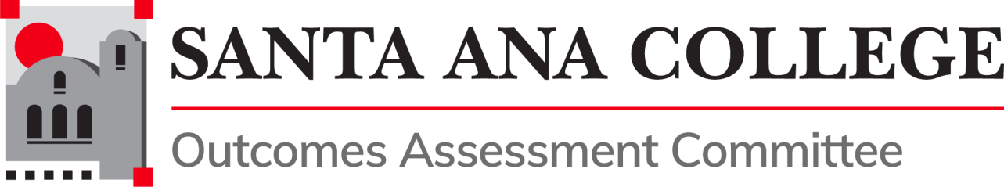

# Meeting Agenda

**May 28, 2020**

**1:30 PM – 3:30 PM**

[**https://cccconfer.zoom.us/j/95596884134**](https://cccconfer.zoom.us/j/95596884134)

The Committee develops, maintains and assists in outcomes assessment practices for Instruction, Student Services, and Administrative Units at the College level.

The Committee is responsible for informing and monitoring the policies and processes that will guide the college community through its work on outcomes assessment.

## Public Comment

1. Approval of Minutes
2. Department Reports
3. Projects
4. Accreditation
5. Professional Development
6. Guided Pathways
7. Nuventive
8. Competency-Based Education
9. Other
10. Upcoming Meetings (1:30 PM – 3:30 PM, Zoom):   
      
    June 2, 2020 June 16, 2020